A Project Report on

**Paddy Leaf Disease Detection with Severity Estimation**

**Submitted by:**

**Rithwik Karne - 100522733092**

**Srinivas Pochempelly - 100522733098**

**Harshitha Rikka - 100522733100**

**Under the supervision of**

**Dr. V. B. NARASIMHA**

**Assistant Professor, Department of CSE,**

**UCE(A), OU, Hyderabad-500007**

**DEPARTMENT OF COMPUTER SCIENCE AND ENGINEERING,**

**UNIVERSITY COLLEGE OF ENGINEERING(A),**

**OSMANIA UNIVERSITY, HYDERABAD-500007**

**JUNE-2025**

2022 – 2026

UNIVERSITY COLLEGE OF ENGINEERING (AUTONOMOUS)

OSMANIA UNIVERSITY, HYDERABAD – 500007

**CERTIFICATE**

This is to certify that the Mini Project work titled " **Paddy Leaf Disease Detection with Severity Estimation**" submitted by **Rithwik Karne, Srinivas Pochempelly, Harshitha Rikka** students of the Department of Computer Science and Engineering, University College of Engineering, Osmania University, is a record of the bonafide work carried out by them during the academic year 2025-26. The project is submitted in partial fulfilment of the requirements for the award of the degree of Bachelor of Engineering in Computer Science and Engineering. The work has been carried out under the supervision of **Dr. V. B. NARASIMHA**, and it is to the best of my knowledge that the work is original and reflects the sincere efforts of the students.

Signature of the Supervision Signature of the Head of the Dept.

**Dr. V. B. NARASIMHA PROF. P. V. SUDHA**

Assistant Professor, Professor,

Department of CSE, Department of CSE,

University College of Engineering, University College of Engineering,

Osmania University Osmania University

**DECLARATION**

We **Rithwik Karne, Srinivas Pochempelly, Harshitha Rikka** students of the Department of Computer Science and Engineering, University College of Engineering, Osmania University, hereby declare that the work presented in this Mini Project titled " " **Paddy Leaf Disease Detection with Severity Estimation** " is an original contribution carried out by us during the academic year 2025-26. This project report is submitted in partial fulfilment of the requirements for the degree of Bachelor of Engineering in Computer Science and Engineering. The project work has not been submitted elsewhere for the award of any degree or diploma.

We affirm that no part of this report is plagiarized, and wherever references have been made, they have been appropriately cited. The findings and analysis presented in the report are based on our genuine and authentic work under the guidance of **Dr. V. B. NARASIMHA**.

We further declare that we have adhered to ethical practices throughout the research and project development process, maintaining academic integrity at every stage. The data, analysis, and outcomes of this report are factual to the best of our knowledge, and we take full responsibility for the contents of this submission.

**Rithwik Karne – 100522733092**

**Srinivas Pochempelly – 100522733098**

**Harshitha Rikka - 100522733100**

**ACKNOWLEDGEMENT**

We would like to express our deep sense of gratitude and whole-hearted thanks our project guide **Dr. V. B. NARASIMHA**, Professor at Department of Computer Science and Engineering, University College of Engineering Osmania University, for giving us the privilege of working under his guidance, with tremendous support and cogent discussion, constructive criticism, and encouragement throughout this dissertation work carrying out the project work. We also thank him for his support from the department and for making all the resources available to us students. We also extend our thanks to the entire faculty of the Department of Computer Science and Engineering, University College of Engineering, Osmania University who encouraged us throughout the course of our Bachelor's degree and allowed us to use the many resources present in the department. Our sincere thanks to our parents and peers for their valuable suggestions, morals, strength, and support for the completion of our project.

**ABSTRACT**

Paddy is one of the most significant staple crops worldwide, particularly in Asia. However, paddy cultivation is frequently affected by various leaf diseases that can severely reduce yield and quality if not identified and treated promptly. Traditional manual disease detection methods are labor-intensive, time-consuming, and often lead to inaccurate or delayed diagnoses due to human error or insufficient expertise.

Several automated disease detection systems have been proposed in recent studies using deep learning techniques such as VGG19-based Convolutional Neural Networks and hybrid models combining CNN with Random Forest classifiers. While these systems achieved moderate classification accuracy, they suffered from key limitations including smaller disease class coverage, high computational cost, lack of real-time capability, absence of input image validation, and failure to provide severity estimation of the detected diseases.

This project proposes an advanced **Paddy Leaf Disease Detection and Severity Estimation System** using the **EfficientNetB0 deep learning model** integrated into a real-time web application. The system is designed to validate whether the uploaded image contains a paddy leaf, classify the type of disease from ten predefined categories, and estimate the severity of the disease using image processing techniques. The application features a leaf verification module, precise green masking, exclusion of irrelevant background areas, and disease region visualization. The system not only improves classification accuracy but also provides pixel-wise severity estimation, enabling farmers and agricultural experts to make timely and informed decisions. The proposed solution is lightweight, efficient, and suitable for real-time deployment, significantly improving over existing methods.

**INDEX**

| **S. No** | **Section Title** | **Page No.** |
| --- | --- | --- |
| 1 | Introduction | 2 |
| 2 | Literature Survey | 2 |
| 2.1 | VGG19-Based Paddy Leaf Detection | 2 |
| 2.2 | CNN + Random Forest Hybrid Approach | 2 |
| 2.3 | Comparison with Existing Models | 3 |
| 3 | System Design | 4 |
| 3.1 | System Architecture | 4 |
| 3.2 | System Modules | 5 |
| 4 | Implementation | 5 |
| 4.1 | Tools and Technologies | 5 |
| 4.2 | Dataset | 5 |
| 4.3 | Model Training | 6 |
| 4.4 | Leaf Validation | 7 |
| 4.5 | Disease Area Detection | 7 |
| 4.6 | Severity Estimation22 | 7 |
| 4.7 | Web Application | 7 |
| 4.8 | Sample Workflow | 7 |
| 4.9 | Sample Outputs | 8 |
| 5 | Results and Discussions | 8 |
| 5.1 | Model Evaluation Metrics | 8 |
| 5.2 | Accepted Paddy Leaf Image (Input) | 10 |
| 5.3 | Disease Prediction Output | 10 |
| 5.4 | Summary Table | 11 |
| 6 | Conclusion | 11 |

**1.Introduction**

Agriculture is the backbone of many economies, particularly in countries like India where paddy (rice) is a major staple crop. Paddy leaf diseases are one of the primary threats to paddy cultivation, significantly impacting yield quality and quantity. Early and accurate detection of these diseases is essential for preventing large-scale crop damage and ensuring food security.

Traditionally, disease identification in paddy leaves is performed manually by farmers or agricultural experts based on visual symptoms. However, this manual process is not only time-consuming but also prone to human errors and inconsistent results, especially when the symptoms are subtle or closely resemble multiple diseases. In addition, manual methods may delay timely intervention, resulting in severe yield loss.

Recent advances in machine learning and deep learning have shown great potential in automating plant disease detection. Convolutional Neural Networks (CNNs), in particular, have proven highly effective for image classification tasks. Several studies have applied CNN-based models for paddy leaf disease detection, achieving reasonable accuracy. However, most existing solutions suffer from key limitations:

* They often focus on a small number of diseases.
* They lack real-time applicability due to heavy model sizes.
* They fail to verify if the uploaded image is a valid paddy leaf.
* They do not estimate the severity of the disease, which is crucial for prioritizing treatment.

To address these challenges, this project proposes a Paddy Leaf Disease Detection and Severity Estimation System using the EfficientNetB0 architecture. The system integrates a web-based user interface where users can upload leaf images and receive instant feedback on:

* Whether the image is a valid paddy leaf.
* The predicted disease class.
* The estimated severity of the disease based on the affected area.

The system is designed to be lightweight, fast, and deployable in real-time environments. It incorporates image processing techniques such as green pixel analysis, contour detection, and background exclusion to improve the accuracy and reliability of disease area identification. Furthermore, it provides visual feedback by displaying the disease-affected regions, helping users understand the infection severity.

This project contributes a comprehensive, efficient, and practical solution that bridges the gap between research and real-world field applications, ultimately aiming to assist farmers in making quick and informed decisions to protect their crops.

**Problem Statement**

Paddy is one of the most widely cultivated crops in the world, and paddy leaf diseases significantly threaten agricultural productivity and global food security. Manual detection of these diseases is time-consuming, prone to human error, and often results in delayed treatment, leading to massive crop losses. There is a pressing need for an **automated, accurate, and real-time system** that can:

* Classify the disease affecting the leaf.
* Estimate the severity of the disease based on the affected area.

An ideal system should also be user-friendly, support real-time processing, and be deployable in mobile or web-based platforms to aid farmers and agricultural experts directly in the field.

**2. Literature Survey**

Several researchers have proposed methods for paddy leaf disease detection using traditional Convolutional Neural Networks (CNNs) and hybrid machine learning techniques.

**2.1 VGG19-Based Paddy Leaf Detection**

* **Source:** VGG19 Enhanced Convolutional Neural Network for Paddy Leaf Disease Detection
* **Summary:** Utilized VGG19 for paddy leaf disease classification with three disease classes and one healthy class. Achieved an accuracy of 91.19%.
* **Limitation:** High computational cost, no severity estimation, no real-time validation for input images.

**2.2 CNN + Random Forest Hybrid Approach**

* **Source:** A Comprehensive Study on Paddy Leaf Disease Detection using CNN and Random Forest
* **Summary:** Combined CNN feature extraction with Random Forest classification. Achieved 92.19% accuracy across five paddy diseases.
* **Limitation:** No severity estimation, higher computational complexity due to hybrid model, no leaf validation module.

**2.3 Comparison with Existing Models**

|  |  |  |  |
| --- | --- | --- | --- |
|  | **VGG19 Paper** | **CNN + Random Forest Paper** | **Proposed System** |
| Model | VGG19 | CNN + Random Forest | EfficientNetB0 |
| Accuracy | 91.19% | 92.19% | 95% |
| Number of Classes | 4 | 5 | 10 |
| Severity Estimation | No | No | Yes |
| Leaf Validation | No | No | Yes |
| Real-Time Capability | No | - | Yes |
| Lightweight Model | No | - | Yes |

The proposed system outperforms existing works by covering more diseases, providing severity estimation, real-time web interface, and leaf validation.

**3. System Design**

**3.1 System Architecture**

User Uploads image

Not a paddy leaf

Paddy Leaf Validation

No

Yes

Disease Classification

Healthy Leaf

Yes

No

Disease Area Detection

Severity Estimation

Result Displayed

**3.2 System Modules**

* **Image Upload Module:** Validates and stores uploaded images.
* **Paddy Leaf Validation Module:** Uses green pixel detection, contour analysis, and aspect ratio checks to verify whether the uploaded image contains a paddy leaf.
* **Disease Classification Module:** Uses EfficientNetB0 to predict one of ten disease classes.
* **Disease Area Detection Module:** Uses image masking to isolate diseased regions and removes irrelevant backgrounds (sky, dark spots).
* **Severity Estimation Module:** Calculates the disease-affected area and classifies severity as Low, Medium, or High.
* **Results Display Module:** Displays the disease name, severity, percentage affected, original image, and disease-highlighted image.

**4. Implementation**

**4.1 Tools and Technologies**

| **Tool** | **Purpose** |
| --- | --- |
| Python | Core programming |
| Flask | Web framework |
| TensorFlow | Model training and prediction |
| OpenCV | Image processing and masking |
| NumPy | Numerical operations |
| HTML/CSS | Web interface |

**4.2 Dataset**

* The dataset consists of **paddy leaf images classified into 10 categories**: Bacterial Leaf Blight, Bacterial Leaf Streak, Bacterial Panicle Blight, Blast, Brown Spot, Dead Heart, Downy Mildew, Hispa, Normal, Tungro.
* <https://www.kaggle.com/datasets/dasa7753912/new-paddy-doctor-paddy-disease-classification?select=paddy-disease-classification>

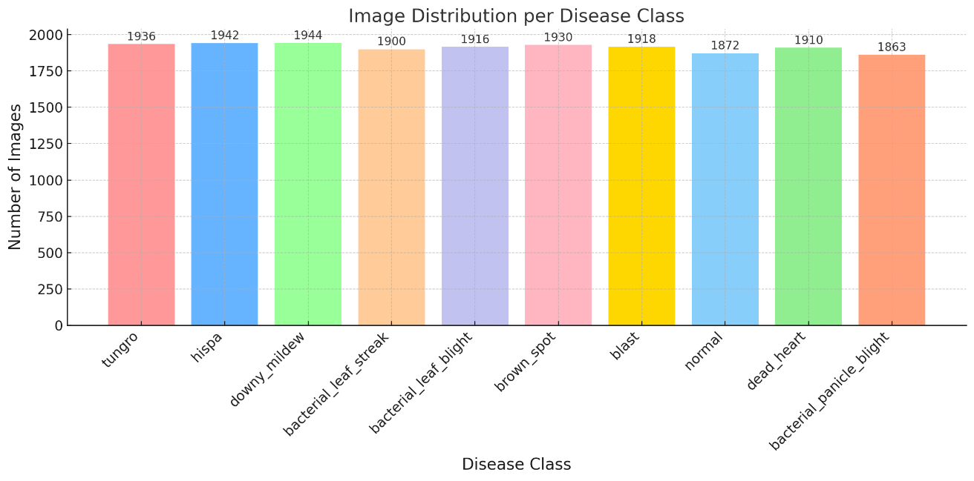

Figure 1: Training dataset image distribution

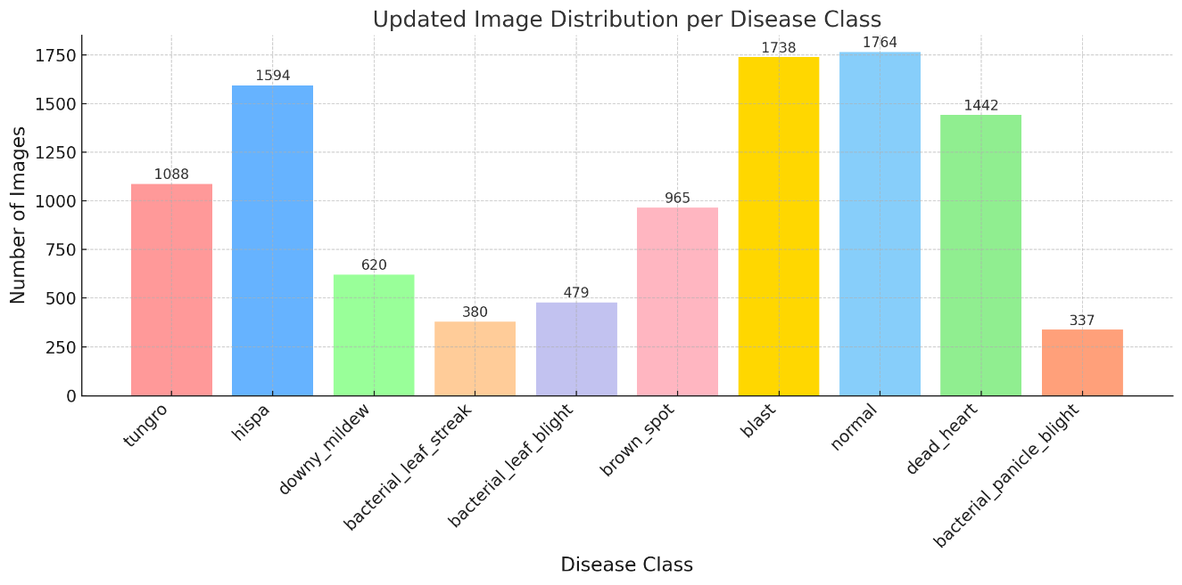

Figure 2: Testing dataset image distribution

**4.3 Model Training**

* Model: **EfficientNetB0**
* Dataset Preprocessing: Image resizing to 224x224, data augmentation, class balancing using class weights.
* Initial Training: Top layers trained with frozen base model.
* Fine-tuning: Entire model unfrozen and trained with a lower learning rate.
* Performance Evaluated with Accuracy, Confusion matrix and Classification Report.

**4.4 Leaf Validation**

* **Green Pixel Check:** Ensures minimum 5% green area.
* **Contour Detection:** Confirms presence of leaf-like structures.
* **Aspect Ratio Check:** Ensures paddy leaf’s typical elongated shape.

**4.5 Disease Area Detection**

* Green leaf area is isolated using HSV colour masking.
* Sky blue and dark regions are excluded.
* Diseased areas are detected based on colour ranges commonly associated with disease symptoms.

**4.6 Severity Estimation**

* Disease area vs. total leaf area is calculated pixel-wise.
* Severity is classified as:
  + **Low:** <30% affected
  + **Medium:** 30%-60% affected
  + **High:** >60% affected

**4.7 Web Application**

* Built with Flask.
* Supports real-time image upload and prediction.
* Provides instant visual feedback.
* Cleans up old uploaded files automatically to manage storage.

**4.8 Sample Workflow**

1. User uploads an image of a paddy leaf.
2. System validates whether it is a paddy leaf.
3. Model predicts the disease.
4. If diseased, severity is estimated and affected areas are visualized.
5. Results are displayed on the web page.

**4.9 Sample Outputs**

* Disease Name: Example: "Tungro"
* Severity: High
* Visual Outputs:
  + Original Image
  + Disease Affected Region

**5. Results and Discussions**

**5.1 Model Evaluation Metrics**

**5.1.1 Confusion Matrix**

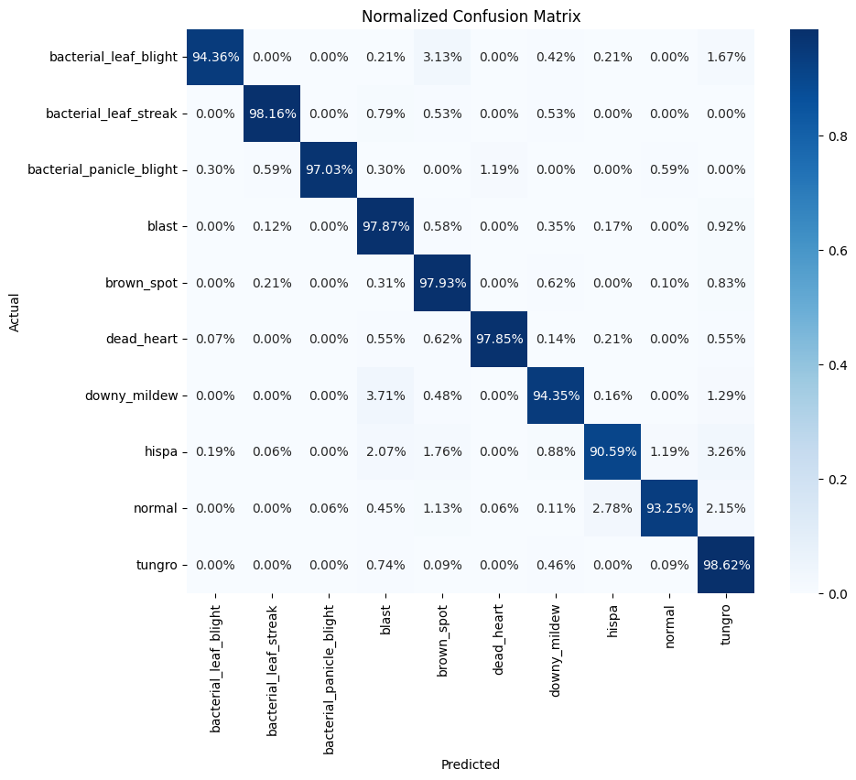

Figure 3: Confusion Matrix of the Paddy Leaf Disease Classification Model.

**5.1.2 Classification Report**

| **Class Name** | **Precision** | **Recall** | **F1-Score** | **Support** |
| --- | --- | --- | --- | --- |
| Bacterial Leaf Blight | 0.99 | 0.94 | 0.97 | 479 |
| Bacterial Leaf Streak | 0.98 | 0.98 | 0.98 | 380 |
| Bacterial Panicle Blight | 1.00 | 0.97 | 0.98 | 337 |
| Blast | 0.95 | 0.98 | 0.96 | 1738 |
| Brown Spot | 0.91 | 0.98 | 0.95 | 965 |
| Dead Heart | 1.00 | 0.98 | 0.99 | 1442 |
| Downy Mildew | 0.94 | 0.94 | 0.94 | 620 |
| Hispa | 0.96 | 0.91 | 0.93 | 1594 |
| Normal | 0.99 | 0.93 | 0.96 | 1764 |
| Tungro | 0.89 | 0.99 | 0.93 | 1088 |
|  |  |  |  |  |
| **Metric** | **Precision** | **Recall** | **F1-Score** | **Support** |
| Accuracy |  |  | 0.96 | 10407 |
| Macro Avg | 0.96 | 0.96 | 0.96 | 10407 |
| Weighted Avg | 0.96 | 0.96 | 0.96 | 10407 |

Table 5.1: Precision, Recall, and F1-Score for each Paddy Leaf Disease Class.

**5.1.3 Accuracy and Loss Curves**

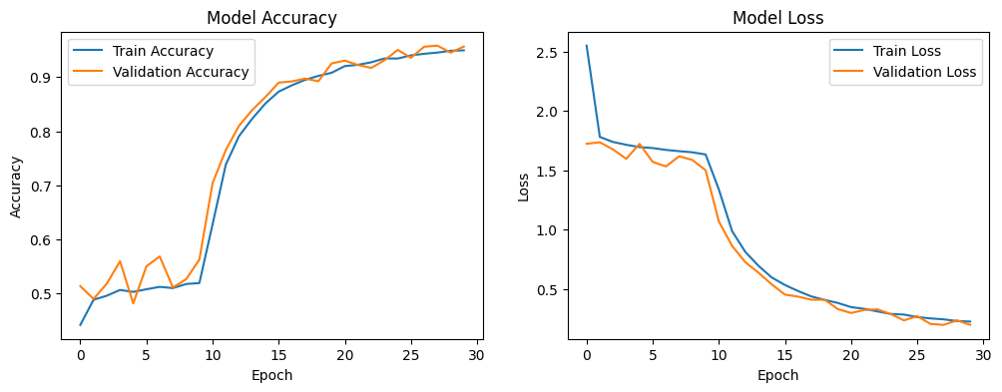Figure 4: Model Accuracy Curve and Model Loss Curve.

**5.2 Accepted Paddy Leaf Image (Input)**

* Image uploaded by the user.

Example:  
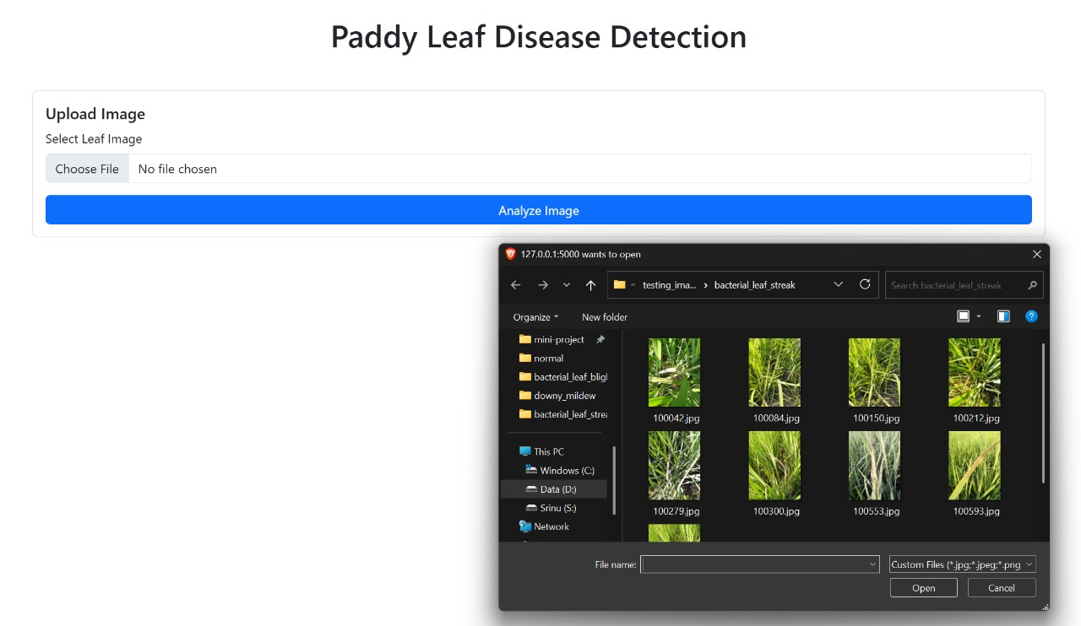

Figure 5: Uploaded Paddy Leaf Image

**5.3 Disease Prediction Output**

* Display the predicted disease result from the system.

Example:  
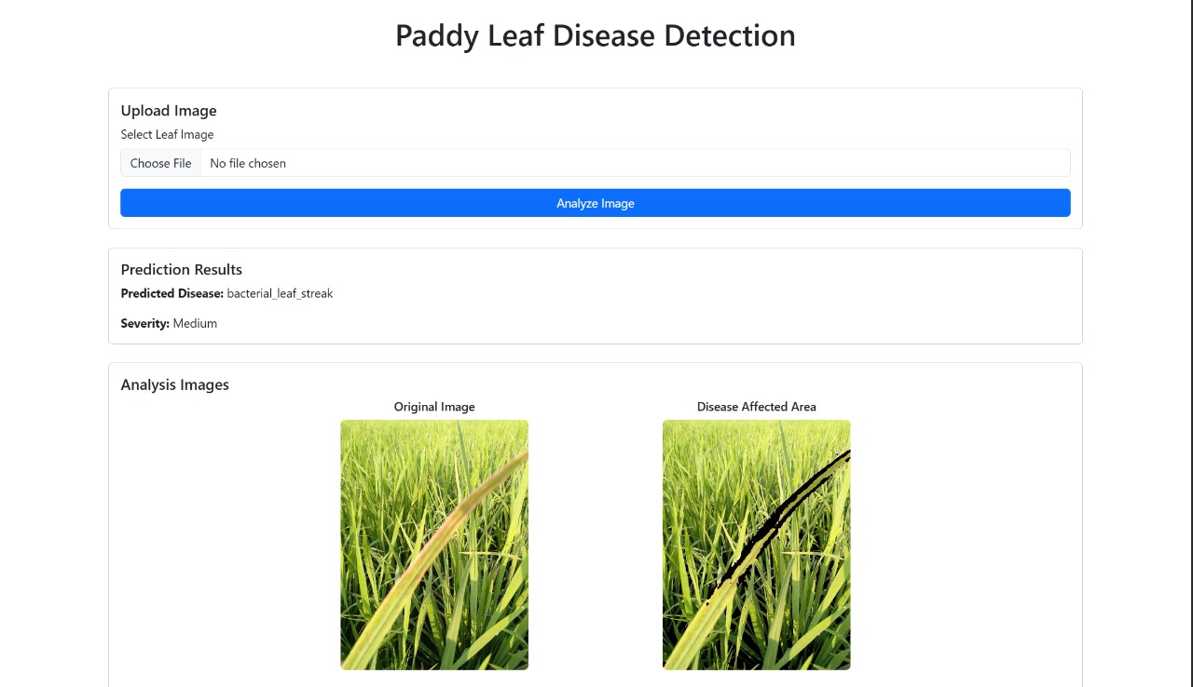

Figure 6: Predicted Disease and Severity on Web Interface

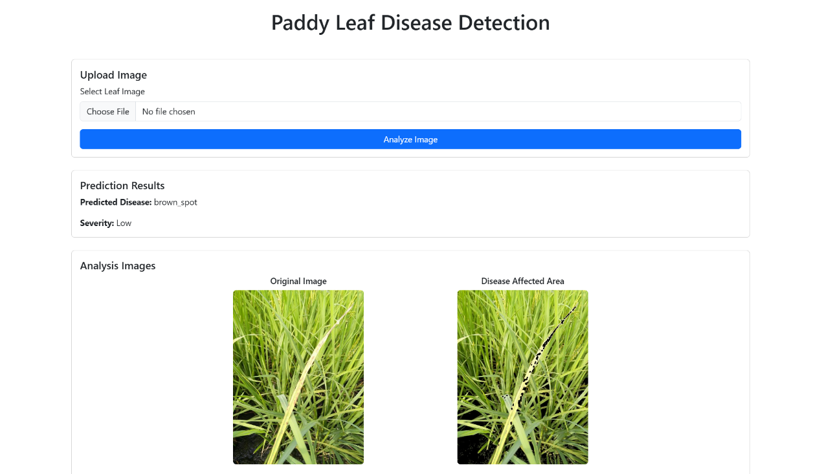

Figure 7: Predicted Disease and Severity on Web Interface

**5.4 Summary Table**

| **Image Name** | **Predicted Disease** | **Severity** |  |
| --- | --- | --- | --- |
| Fig. 6 | Bacterial leaf streak | Medium |  |
| Fig. 7 | Brown spot | Low |  |

**6. Conclusion**

The proposed system efficiently detects paddy leaf diseases and estimates severity using a lightweight deep learning model combined with image processing techniques. It offers:

* Real-time disease prediction.
* Visual feedback on diseased areas.
* Practical deployment potential for mobile and web platforms.

The system outperforms existing models in terms of disease coverage, speed, accuracy, and usability